[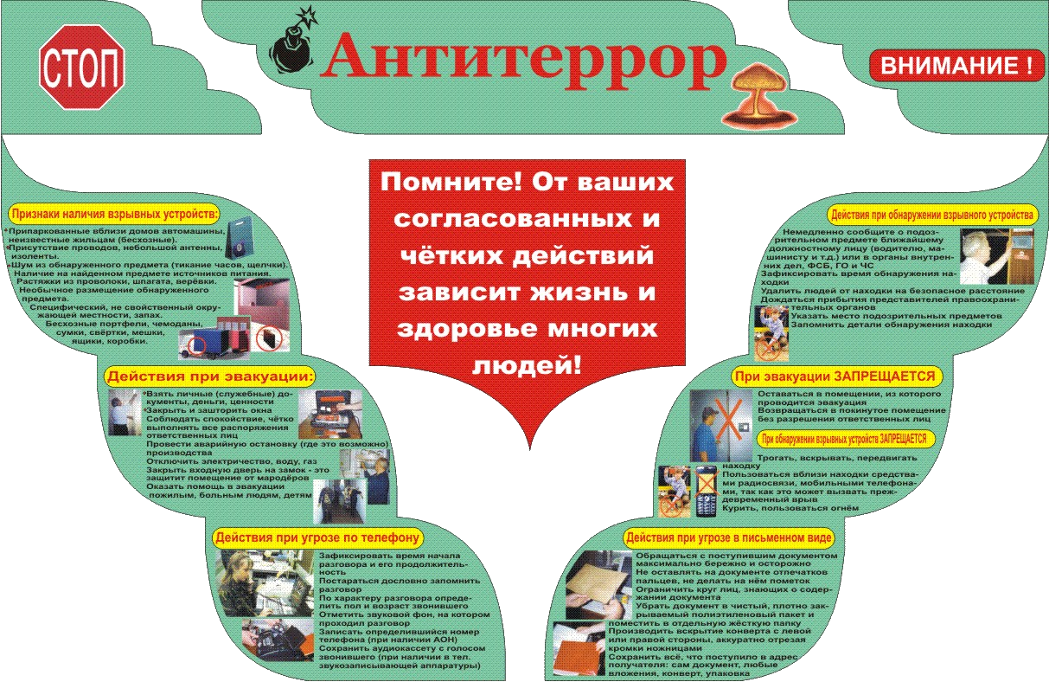](http://go.mail.ru/redir?src=5a4868&via_page=1&oqid=77c7d5049547b636&type=sr&redir=eJzLKCkpsNLXT87PLUgsLtbNTU1KzdED8vRKE_UT80oyS1KLivKLdLMTi0oy87IzdVNyKhN1i0tS81ISdct0U1JLirPzc3WLE1NK9TJKcnMYGAxNzU0sLQ0MTIwYDvF9OCed4vhZLtj1n7ll7AYAe-ondw)